*ISAD3000 Capstone Computing Project 1 Milestone 5 Group Report*

***Group E8: Amristar Industry Project [Virtual Jukebox]***

Group Members:

Austin Bevacqua, Bradley van der Zwan, Dillon Vincent,   
Ryan Webster, Tanaka Chitete

Table of Contents

***Capstone Milestone 5 Group Report*** ***2***

Study Contract **2**

Submitted Deliverables **3**

Agile Report **4**

Client/Supervisor Meetings 4

Group Meetings 4

Start/End of Sprint Meetings 4

Stand-up Meetings 4

Progress Tracking 5

Sprint 1 5

Sprint 2 5

Sprint 3 5

Sprint 4 5

Sprint 5 9

Reflection 10

Group Toggl Summaries 10

# ***Capstone Milestone 5 Group Report***

*Group E8: Amristar Industry Project [Virtual Jukebox]*

# Study Contract

See below for the study contract the group has created, and the semester 1 assessment and deliverables sheet provided by Amristar – the industry partner.

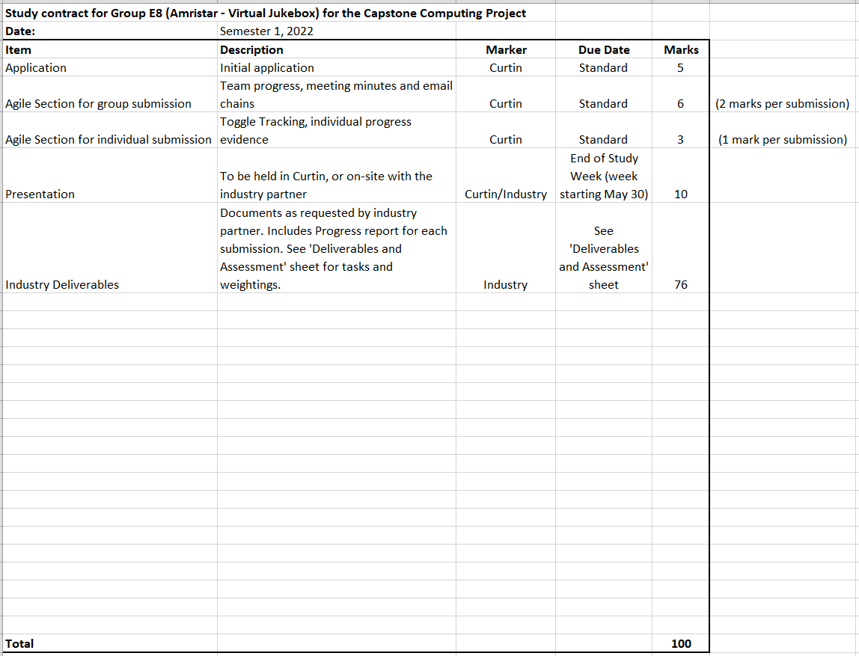

# Submitted Deliverables

The Solution Architecture Specification (SAS), or simply Solution Specification is not yet finalised as it is not yet due. The following link contains the draft to the SAS.

<https://drive.google.com/drive/folders/1Fy05gLiMQIQDEUoGMzEH4r93pVZzpvQk?usp=sharing>

The following link contains two submitted drafts of the Software Requirements Specification (SRS) deliverable for Amristar (v0.1, v0.2), as well as the final submission (v1.0).

<https://drive.google.com/drive/folders/18p0U6w9yyfh61fs7rk_411_MaoRMnZaE?usp=sharing>

The following link contains the submitted Project Plan draft and the final version for Amristar.

<https://drive.google.com/drive/folders/17VMDKc2MeCLrHJlokPBq67LVzy6Rfbfr?usp=sharing>

The following link contains the Progress Report and its submitted draft for the last reporting period, which was submitted to Amristar alongside the final TIS version.

<https://drive.google.com/drive/folders/17VlgypQ8n4dG-B56gFlGVpeyw84zuI4s?usp=sharing>

(See previous group milestone reports for older submitted deliverables)

# Agile Report

(Spans 7/05/2022 to 27/05/2022)

## Client/Supervisor Meetings

Both the client and the supervisor is Amristar. From 7/05/2022 to now (27/05/2022), the group has had three meetings with Amristar. The co-supervisor (or Curtin supervisor) is Senjian An.

In this reporting period, the three supervisor meetings were held on 9/05/2022, 16/05/2022, and 23/05/2022. No meetings were held with the Curtin supervisor, but emails were exchanged.  
  
See below for a link to the group folder storing the meeting minutes taken at each of these meetings.

Supervisor meeting minutes’ link:

<https://drive.google.com/drive/folders/1rKsgHWpck5Wpd935lpXTCyADSaPFoQgS?usp=sharing>

Several email chains were developed in communication with the supervisor(s) to arrange these meetings and to send them the minutes after they ended. See below for a link to the group folder containing these email chains, as well as emails of group-meeting minutes sent to the co-supervisor, and other important emails sent to and from supervisors.

Supervisor email chains link: <https://drive.google.com/drive/folders/1J1YHJV_EPKmhYHHSK6_tLOWLClF0pZ2f?usp=sharing>

## Group Meetings

Group meeting minutes link: <https://drive.google.com/drive/folders/1OImhOwUw_PIgKJ7r6JA-oma24w2zfaJa?usp=sharing>

### Start/End of Sprint Meetings

From the time-frame of the last reporting period to now, there has been a total of one sprint planning meeting (for sprint 5), and one sprint retrospective meeting (for sprint 4) held amongst the team.

Sprint 5’s planning meeting was held online on 18/05/2022. During this meeting, plans for activities to be undertaken for the respective sprints were discussed, with the team’s JIRA page being updated accordingly.

Sprint 4’s retrospective meeting was also held online on 18/05/2022. This meeting consisted of creating action items based on what could be improved upon that sprint, as well as considering which aspects went well. See the minutes of these meetings for reflections on those sprints recorded during those meetings.

### Stand-up Meetings

There have been a total of 3 stand-up meetings during this reporting period, each of which involved discussions of individual member progress and issues. In addition to these meetings, online communication was frequently made to address certain aspects that team members had issues with for specific SAS sections.

These standups were held on 8/05/2022, 11/05/022, and 24/05/2022. The stand-ups involved discussing progress per-person from the last stand-up, and what each team member planned on completing within the next few days in terms of their assigned SAS sections.

## Progress Tracking

### Sprint 1

FInished (See previous group report)

### Sprint 2

FInished (See previous group report)

### Sprint 3

FInished (See previous group report)

### Sprint 4

Finished. (2/05/2022 - 17/05/2022) Sprint 4 involved the creation (but not submission) of the first SAS draft, which included attempts at most headers of the SAS. A list of questions was compiled and sent to the industry partner before the draft submission in order to gauge requirements of each section, and to resolve ambiguities. The email link in the Client/Supervisor meeting section contains an email with these questions. The SAS sections include:

* + Business Requirements and Goals
  + Business Model
  + Solution Architecture Model
  + Detailed Physical Architecture
  + Solution Impact
  + Quality Attributes
  + Success Criteria and Test Plan
  + Phasing, Roadmap, and Implementation Plan

**Burnup Chart**

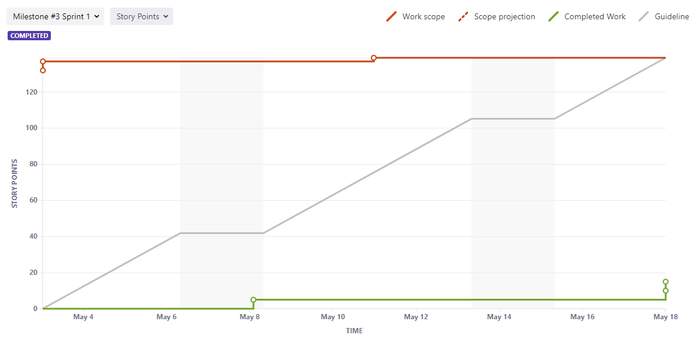

**Burndown Chart**

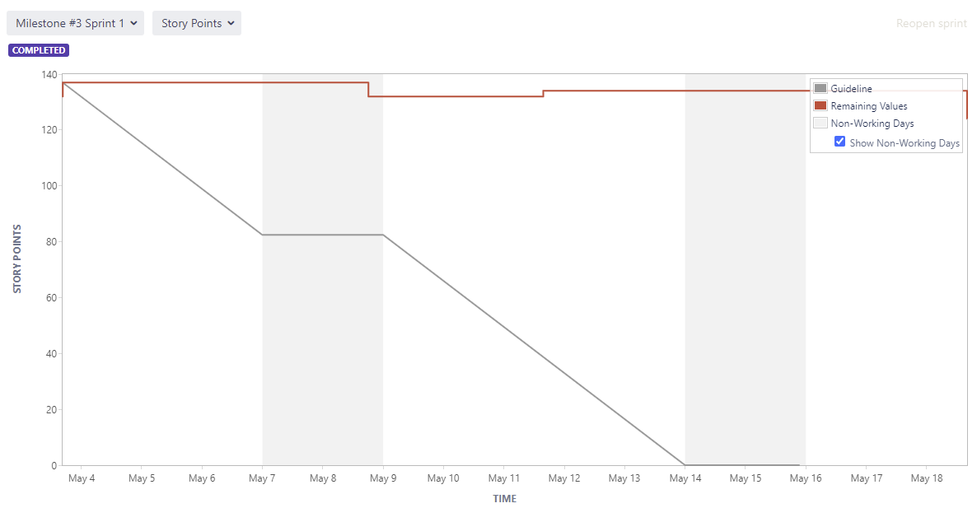

The following list outlines the responsibilities and achievements per person in sprint 4 and sprint 5 so far (see individual submissions for more detail and time spent):

* *Austin Bevacqua:*
  + As scrum master, was in charge of ensuring the group was following the agile process. Made sure the group was keeping Jira up to date, and every member was sticking to their assigned tickets.
  + Added all tickets to Jira with names, and allocated people their tickets.
  + Organised and ran sprint kickoff, retrospective and standup meetings.
  + Kept Jira up to date with current group progress
  + Responsible for completing the following sections of the SAS in drafts 1 and 2:
    - Business Model - Organisational Context
    - Business Model - Current Situation
    - Business Model - Solution Definition
    - Business Model - Actors
    - Business Model - Interactions of Actors
    - Business Model - Use Cases
  + Evidence for these sections is below
  + 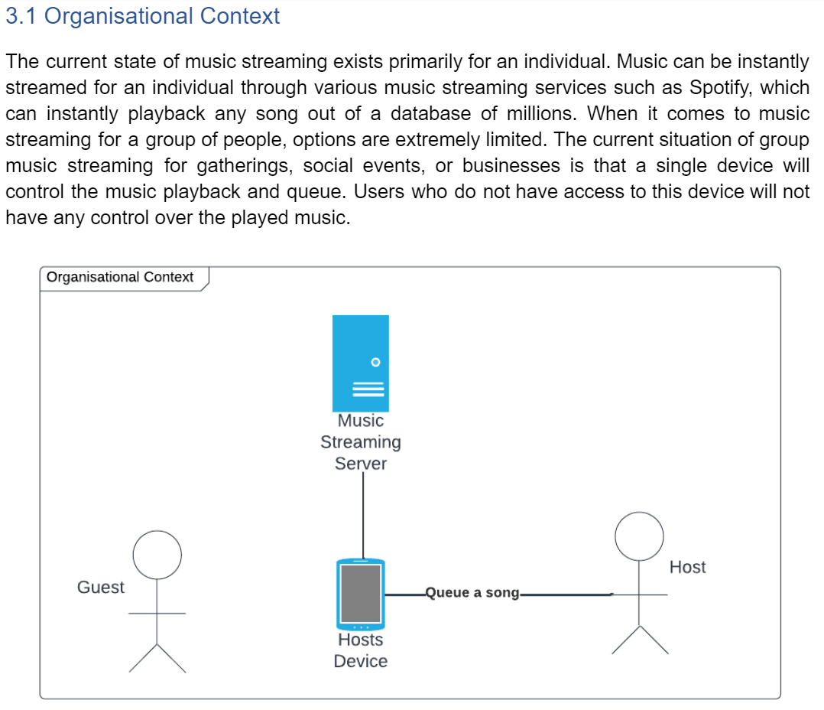
  + 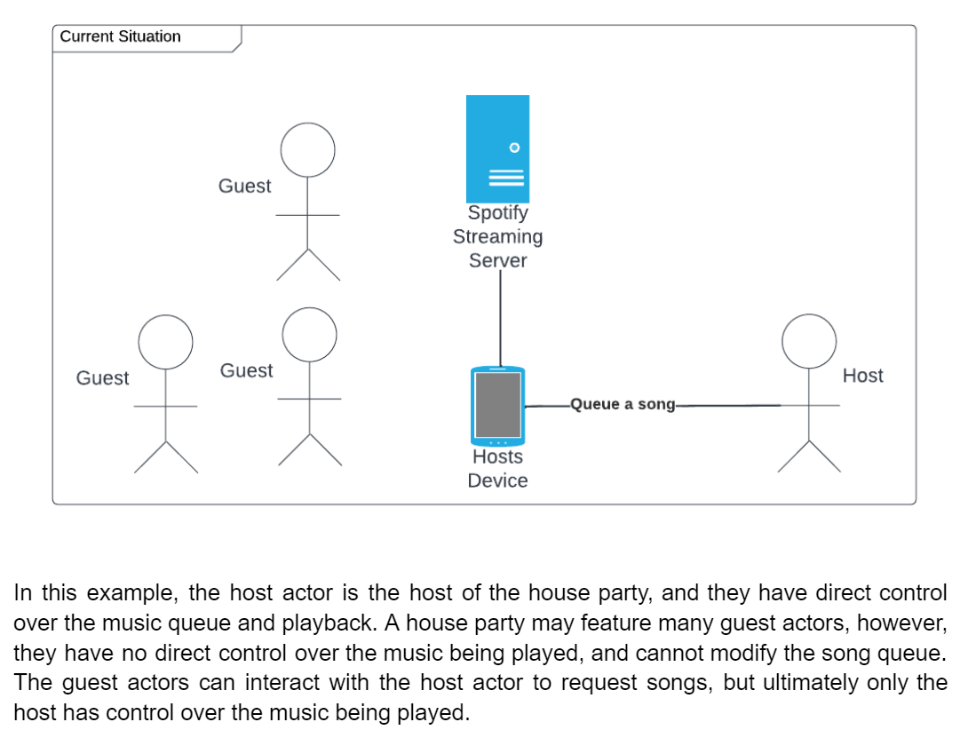
  + 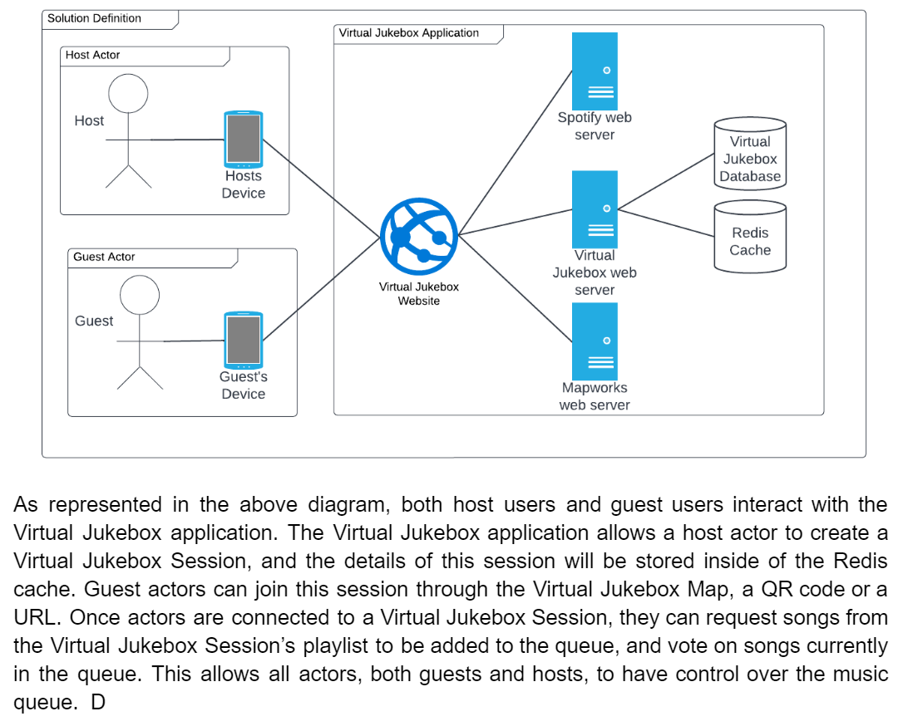
  + 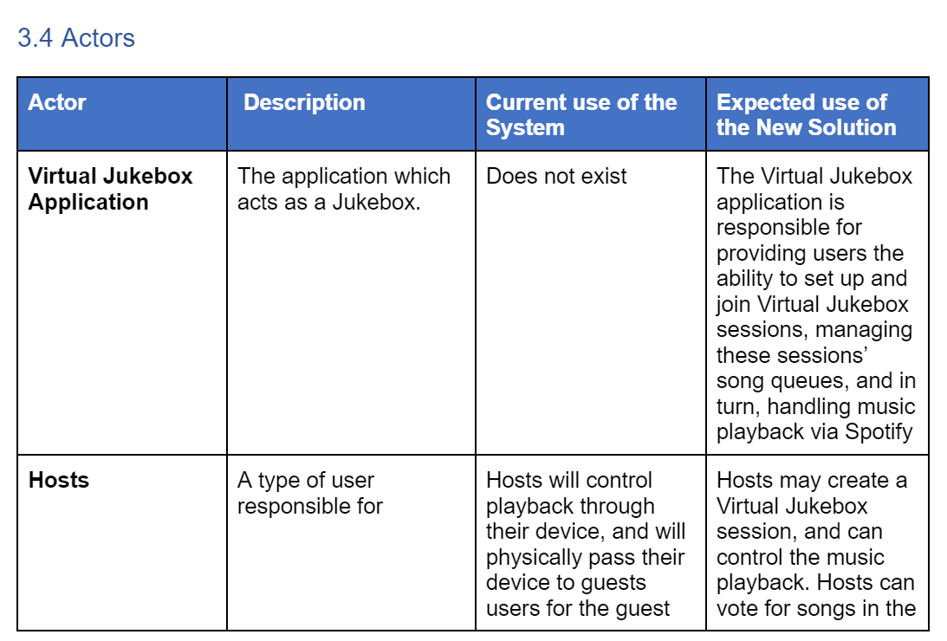
  + 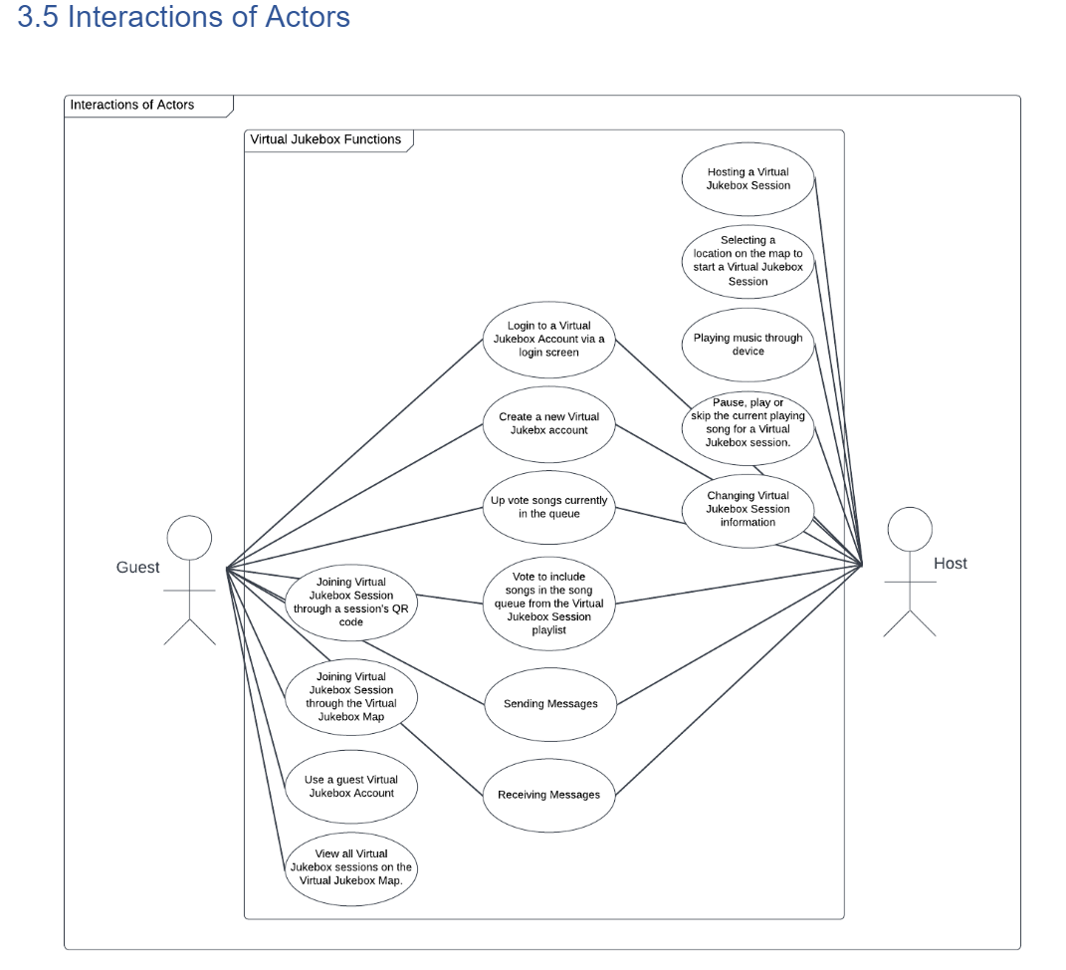
  + 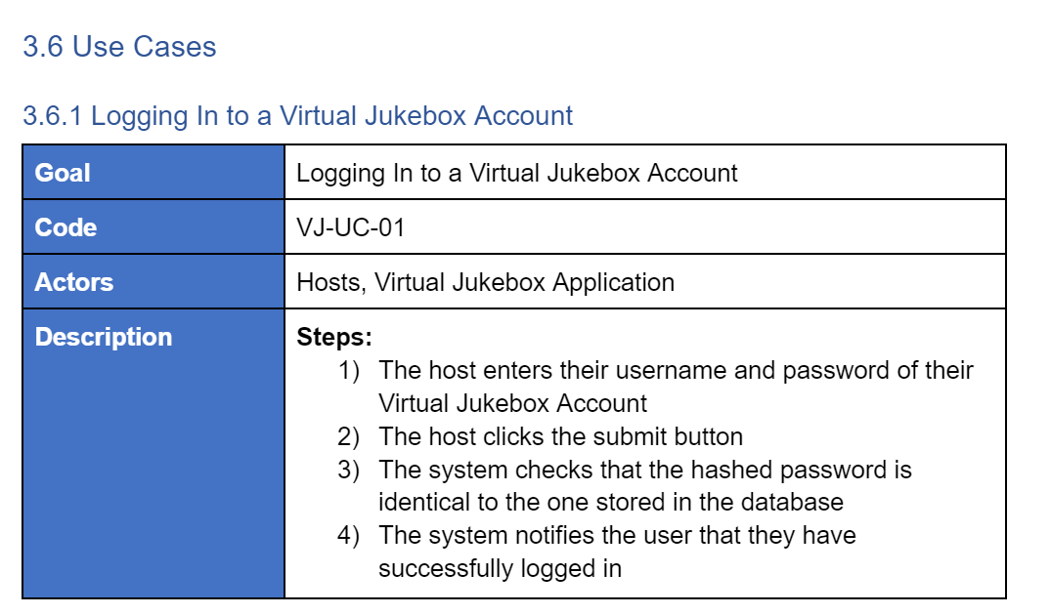
* *Bradley van der Zwan:* 
  + Responsible for all meeting minutes, emails, and email compilations into the shared drive. Also emailed drafts and questions for the SAS.
  + Additionally responsible for putting together the milestone 5 group report and its submission.
  + Responsible for completing the following sections of the SAS in drafts 1 and 2:
    - *Solution Architecture Model*
      * Solution Components (including internal and external components)
      * Integration Specification (Diagram and description)
      * Walk-Throughs (Diagram and table for each use case)
      * Information Model (ERD diagram and description)
  + The following screenshots are evidence of the assigned work (note: only some parts of completed work is shown here. See individual submission for more detailed evidence):

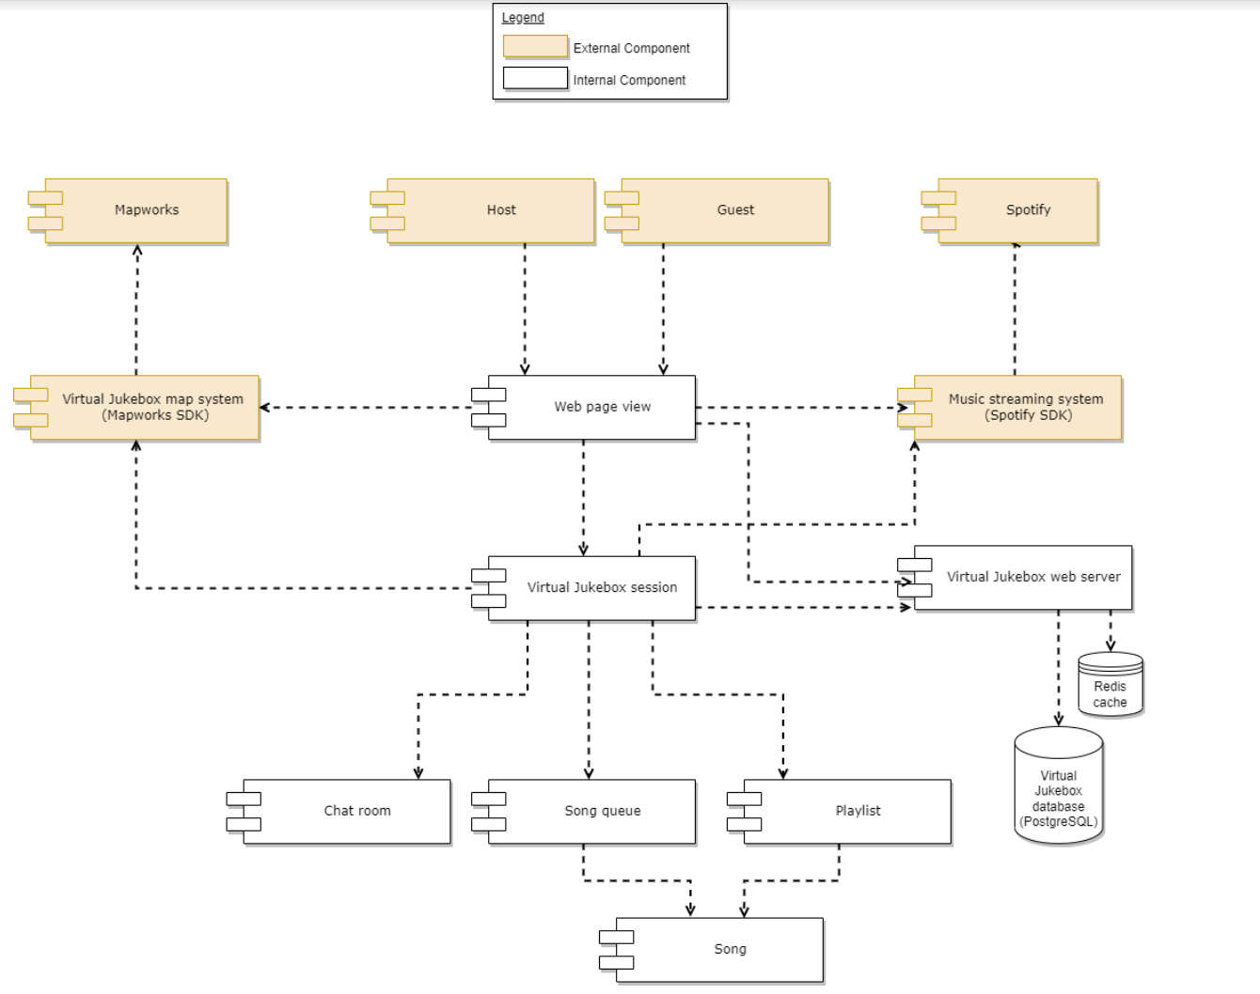

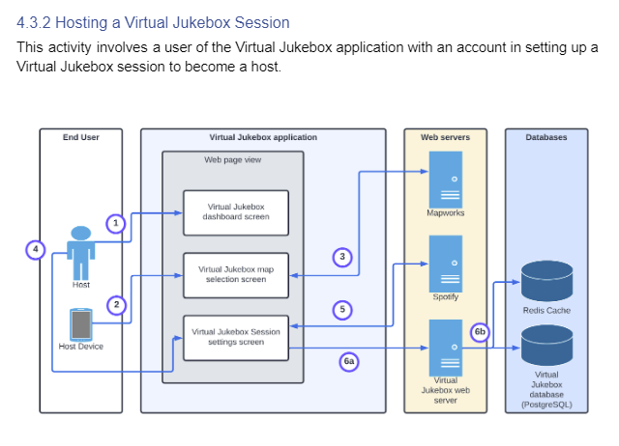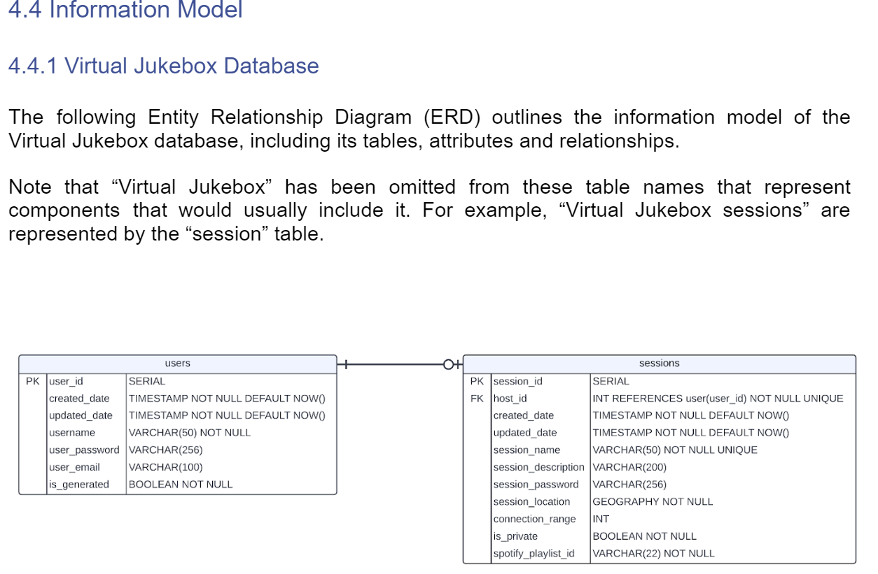

* *Dillon Vincent:*
  + *Attended group meetings and gave input to questions from other group members*
  + *Completed Section 5.1(Network Diagram) in the SAS for draft 1 and 2*
  + *Completed Section 6(Solution Impact) in the SAS for draft 1 and 2*
  + *Completed Section 8( Success Criteria and Test Plan) in the SAS for draft 1 and 2*
  + The following screenshot is of a test plan and Network Diagram, to see more evidence please refer to the individual submission

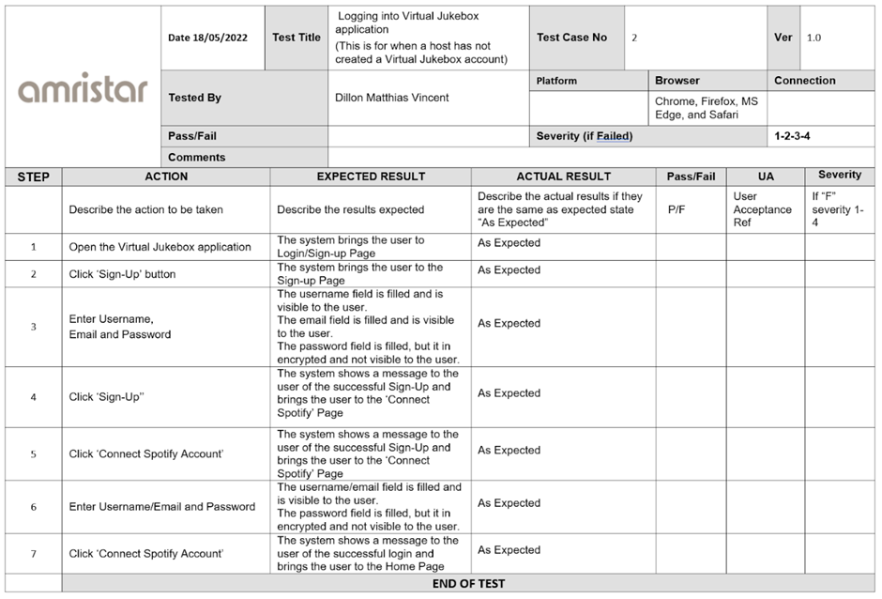

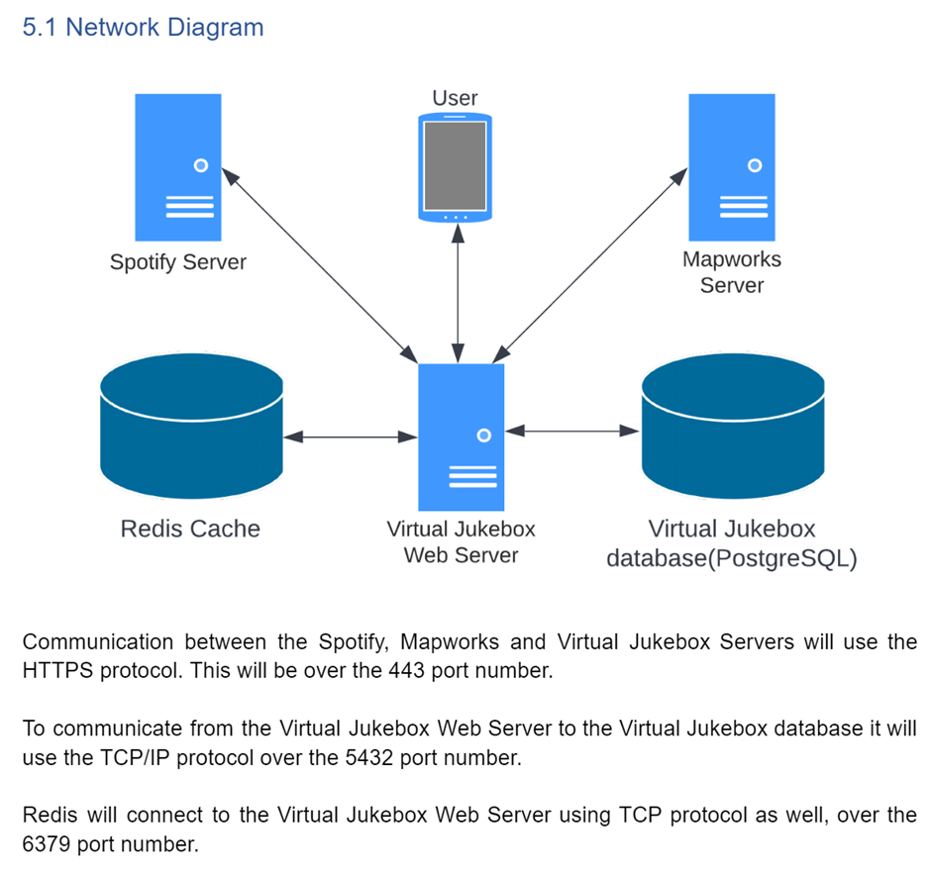

* *Ryan Webster:*
  + Researched Docker in preparation for creation of the Software Architecture Specification Document.
  + Set up Docker locally and created sample Docker images.
  + Investigated ports that must be open for communication between components in the web application, as well as how to communicate between components in the system through the Docker containers.
  + Wrote two drafts outlining the business drivers, high level metrics for success, and the solution requirements of the Virtual Jukebox application.
* *Tanaka Chitete:*
  + contributed solely to the completion of the following sections of the SAS for drafts 1 and 2; and the final submission:
    - Quality Attributes
      * Reliability
      * Availability
      * Serviceability
      * Best Practice Commentary
      * Architecture Commentary
    - Phasing, Roadmap, and Implementation Plan
      * Technical Assumptions
      * Solution Phases and Technical Milestones
      * Implementation Instructions
  + Evidence of work done, is provided in the following screenshots–note, the screenshots detail the contents of the submission as per draft 2, view the final version for more detailed evidence: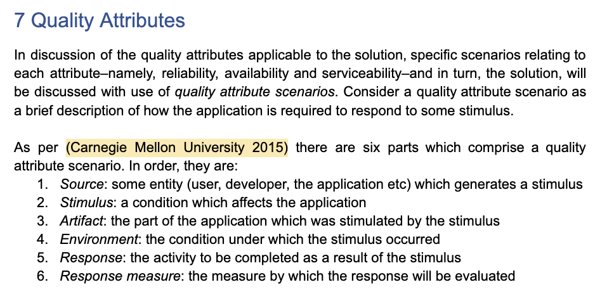

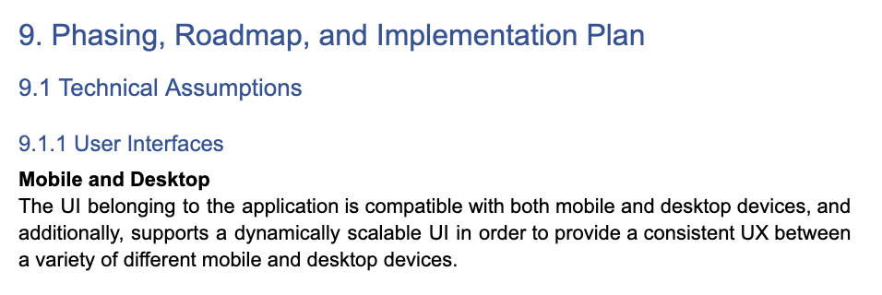

### Sprint 5

Sprint 5 is in progress, and started 18/05/2022. This will involve the submission of the final deliverable (Solution Specification) for Amristar, after the submission of a second draft (submitted 25/05/2022). This sprint will end on 30/05/2022, after the submission of the SAS, and progress report. The first draft of the SAS was submitted during this sprint instead of the planned sprint 4 submission due to high workloads across the team.

The backlog at this current time for the sprint (as shown in JIRA {Based off of the Project Plan deliverable}- includes member assignment and effort estimates) is:

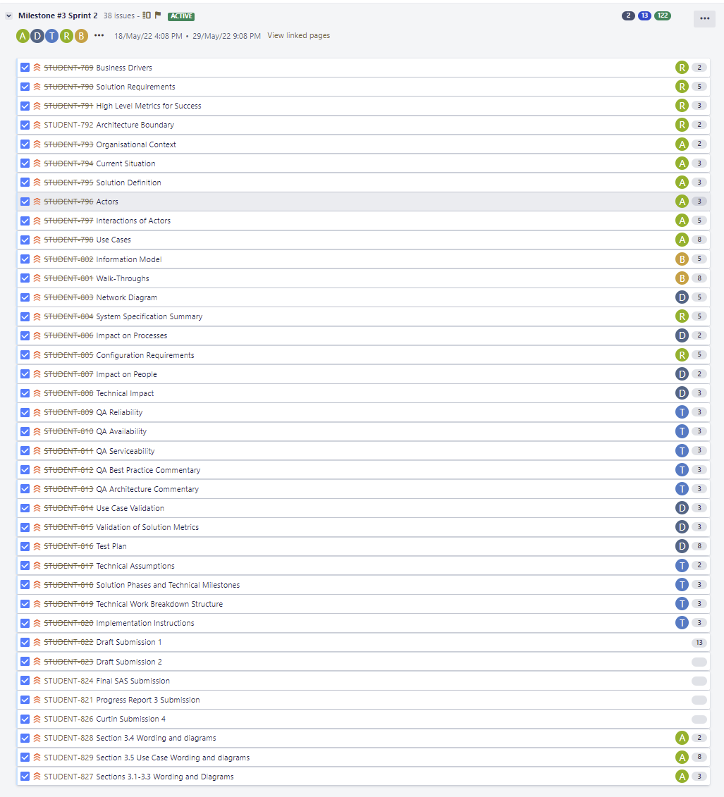

## Reflection

Each group member has been present in every major meeting so far, with only a few absent in a couple stand-up meetings. Some issues have been present throughout sprints 4 and 5 including time constraints conflicting with high workloads from both this and other units, which delayed draft submissions from what was planned. Despite this, feedback from draft 1 was still provided and used to modify the draft for an additional draft (2) submission. A completed version 1.0 SAS is expected to be submitted by the due date (29/05/2022) alongside a progress plan.

## Group Toggl Summaries

Below showcases individual group member’s time spent as per Toggl throughout the reporting period. See individual report submissions for time break-downs per task.

**Austin Bevacqua**

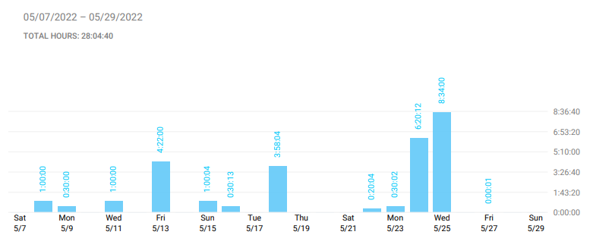

**Bradley van der Zwan**

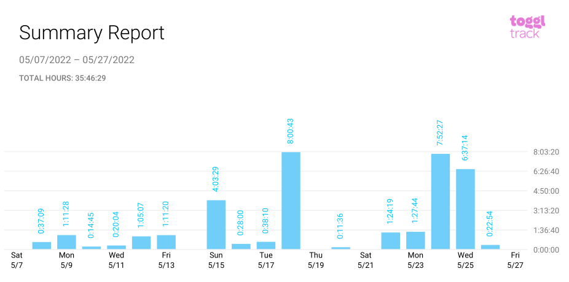

**Dillon Vincent**

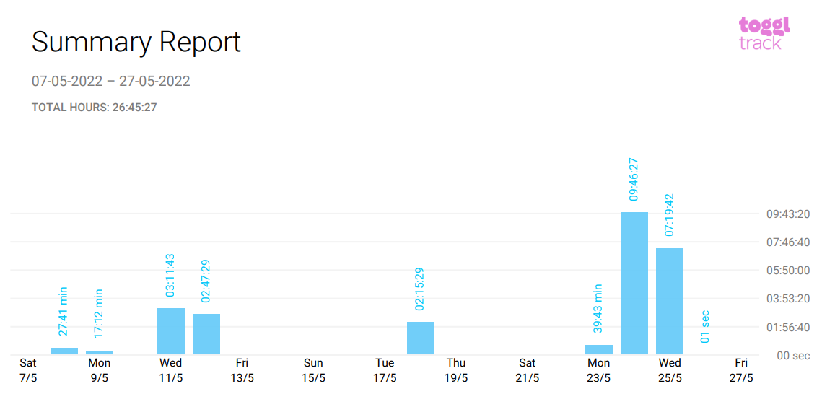

**Ryan Webster**

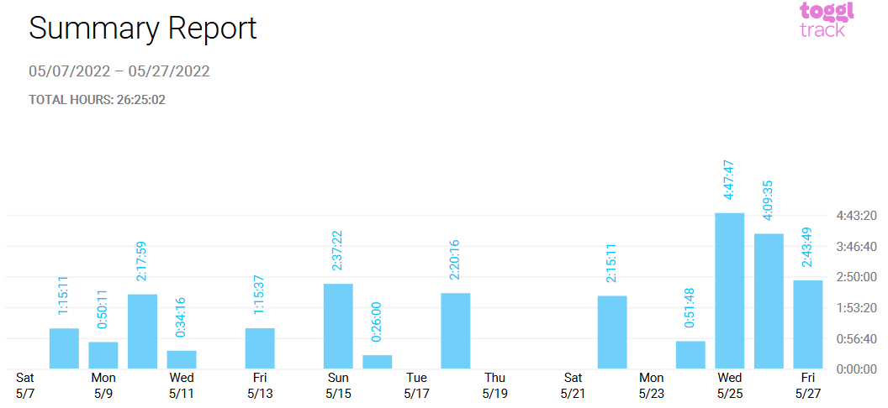

**Tanaka Chitete**

